21-02-2021
Started off with the basic of creating a new instance using the boto3 api.
I then changed under the lecturers advice to never upload credentials to a repo.
This is the reason why the user has to pass in credentials when calling the python script.
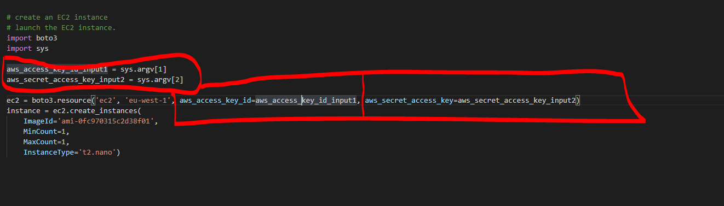

This is the current state of instances when starting the project:

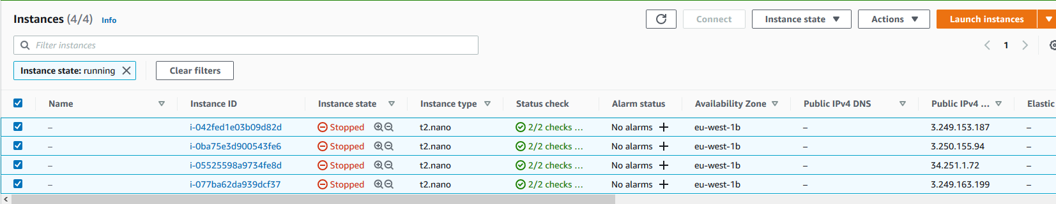

there is now an instance running:

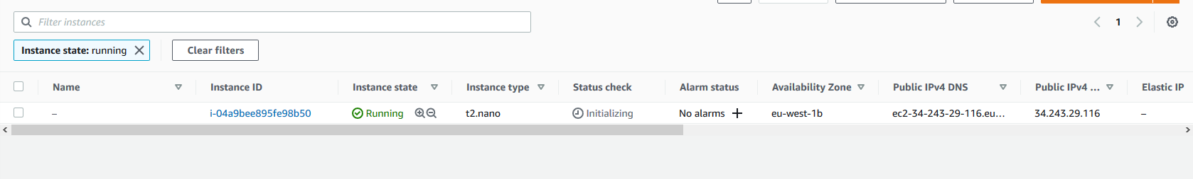

In the next session I will either add to the instance attributes or I will change how I pass in the user credentials

